Please provide the following information and return responses to AASHTO.

***Provide all applicable supporting documentation requested.***

|  |  |
| --- | --- |
| **Plant** |  |
| Name: | **GIA LOI JSC** |
| Physical Address: | **Group 2, Phuoc Hai, Thai Hoa, Tan Uyen city, Bing Duong Province,** |
|  | **Viet Nam** |
|  |  |
| Mailing Address: |  |
| (if different from above) |  |
|  |  |

|  |  |  |
| --- | --- | --- |
| **Primary Contact** | |  |
| Name: | | **Mr Paul Wong** | |
| Title: | | **Director** | |
| Telephone: | | **+84 903905677** | |
| Email: | | **Paul905677@gmail.com** | |
| **Management** |  | | |
| QC Manager: | | **Ho Thi Xuan Tinh** | | |
| Plant Manager: | |  | | |

|  |
| --- |
|  |
| **Facility Classification(s)** (*check all that apply for this location*): |

**Manufacturer**  **Converter (no physical changes)**

**Converter (physical changes)**   **Private Label Distributor**

**Table of Contents**

**Section 1: Standard Specifications** 3

**Section 2: Geotextile Products** 4

**Section 3: Geotextile Roll Identification Markings** 6

**Section 4: Product Information** 7

**Section 5: Sample Reports for Geotextile Testing** 11

**Section 6: Signature** 16

**Section 1: Standard Specifications**

|  |  |  |  |  |
| --- | --- | --- | --- | --- |
| **A) Standard Test Methods and Specifications** | | | | |
| **Item** | | **Standard** | **Date of Your Version** | **Please check if this test is not done for your products** |
| Standard Specification for Geotextile Specification for Highway Applications | | AASHTO M288 | 2022 |  |
| Standard Test Method for Deterioration of Geotextiles from Exposure to Ultraviolet Light and Water (Xenon-Arc Type Apparatus) | | ASTM D4355 | 2021 |  |
| Standard Test Methods for Water Permeability of Geotextiles by Permittivity | | ASTM D4491 | 2022 |  |
| Standard Test Method for Trapezoid Tearing Strength of Geotextiles | | ASTM D4533 | 15 (2023) |  |
| Standard Test Method for Grab Breaking Load and Elongation of Geotextiles | | ASTM D4632 | 2015a (2023) |  |
| Standard Test Method for Determining Apparent Opening Size of a Geotextile | | ASTM D4751 | 2021a |  |
| Standard Test Method for Measuring Mass per Unit Area of Geotextiles | | ASTM D5261 | 10 (2018) |  |
| Standard Test Method for the Static Puncture Strength of Geotextiles and Geotextile-Related Products Using a 50-mm Probe | | ASTM D6241 | 2022a |  |
| Standard Test Method to Determine Asphalt Retention of Paving Fabrics Used in Asphalt Paving for Full-Width Applications | | ASTM D6140 |  |  |
| Standard Test Methods for Identification of Fibers in Textiles (melting point) | | ASTM  D276 |  |  |
| **Comments:** |  | | | |

**Company Test Procedures:**

Please provide hard copies or electronic copies of any company test procedures used at this plant as substitutes for the standard quality control test procedures listed above.

**Section 2: Geotextile Products Produced/Furnished by the Plant**

|  |  |  |
| --- | --- | --- |
| **Product Name** | **Structure**  **(***Woven****: Monofilament, Slit Film, Combination, etc.)***  ***(****Nonwoven****: Needle Punched, etc.*)** | **Distribution Type**  ***(Manufacture, Private Label, Conversion)*** |
| GS40 | ***Slit Film*** | ***Manufacture*** |
| GS46 | ***Slit Film*** | ***Manufacture*** |
| GS55 | ***Slit Film*** | ***Manufacture*** |
| SF30 | ***Slit Film*** | ***Manufacture*** |
|  |  |  |
|  |  |  |
|  |  |  |
|  |  |  |
|  |  |  |
|  |  |  |
|  |  |  |

1. **Production Line Details:**

|  |  |
| --- | --- |
| **Production Line(s)**  (approx. number) | **Products Manufactured on the Production Line(s)** |
| PP woven geotextile | GS40, GS46, GS55  SF30 |

|  |  |  |
| --- | --- | --- |
| **Prime Mfr. #** | **NTPEP Compliant Prime Mfg. Name & Location** | **Date of Agreement between Prime Mfg. and Private Labeler** |
| 1 |  |  |
| 2 |  |  |
| 3 |  |  |
| 4 |  |  |
| 5 |  |  |

1. **Source Manufacturers Used to Supply Converted Product Lines**

1. **Warehouses Used to Distribute Converted Product Line**

|  |  |  |
| --- | --- | --- |
| **Distribution Warehouse Location** | **Company Owned** | **Contract** |
|  |  |  |
|  |  |  |
|  |  |  |
|  |  |  |
|  |  |  |

1. **Manufacturing Plants Used to Produce Product Line:**

Does the company own plants at other locations that produce, or help to produce, one or more of the products within the product line under consideration? YES  NO

If yes, does each plant have its own unique geotextile marking? YES  NO

List other locations:

N/A

**Section 3: Geotextile Roll Identification Markings**

*Please provide a picture (hard copy or electronic) that illustrate your typical geotextile identification markings used at this plant to identify the geotextile rolls.*

|  |
| --- |
| GIA LOI JSC **BM/ĐG05.00** |
| Customer's Name: |
| Product Code: |
| Specification: |
| Tracking Roll Code: |
| Manufacture date: |
| M288 class: |

# Section 4: Product Information (*complete those Sections that apply to your operations*)

|  |  |  |  |  |  |  |  |  |  |  |  |  |  |  |  |  |  |  |  |  |  |  |  |  |  |  |  |  |  |  |  |  |  |  |  |  |  |
| --- | --- | --- | --- | --- | --- | --- | --- | --- | --- | --- | --- | --- | --- | --- | --- | --- | --- | --- | --- | --- | --- | --- | --- | --- | --- | --- | --- | --- | --- | --- | --- | --- | --- | --- | --- | --- | --- |
| **A) QMS Manual Information and Organizational Policies** | | | | | | | | | | | | | | | | | | |  | | | | |  | | | |  | | | | | | | | | |
| 1) QMS Manual Identification: | | | | | | | | | | | | | | | | | | | Quality Manual | | | | | | | | | | | | | | | | | | |
| 2) Date of Latest Revision of Approved QMS: | | | | | | | | | | | | | | | | | | | Oct 10th, 2024 | | | | | | | | | | | | | | | | | | |
| 3) Who in the quality organization has authority to reject produced materials or shut down production? | | | | | | | | | | | | | | | | | | | Ho Thi Xuan Tinh  QA Manager | | | | | | | | | | | | | | | | | | |
| **Comments:** | | | | |  | | | | | | | | | | | | | | | | | | | | | | | | | | | | | | | | |
| **B) Manufacturer QC/QA for Raw Materials** | | | | | | | | | | | | | | | | | | | | **YES** | | | | **NO** | | | | | **N/A** | | | | | | | |
| 1) Identify raw materials received at the plant to form the products in the product line:  Resin: NOTE: Refer to form **BM/TC01**-MATERIAL SPECIFICATIONS in the PRODUCT AND MATERIAL SPEC SHEETS folder. The sheet refers to the manufacturer’s COA, which must be verified by the Material QC technician as per section 2 of the document entitled QC RESPONSIBILITES AND CONTACTS.  Additives (*identify type of additives*): Color Master batch, UV Master batch, Additives:VMX6102  Fibers  Yarns: | | | | | | | | | | | | | | | | | | | | | | | | | | | | | | | | | | | | |
| 2) Describe Raw Material Lot definition and Numbering System:  Resin: Manufacturers’ lot number_  SEE FORM **BM/S01** “FORM ON MONITORING FABRIC PRODUCTION IN THE FABRIC QC SHEETS IN THE FABRIC TRACEABILITY FOLDER. IT INCLUDES SPECIFIC AMOUNTS FOR RESIN, LOT NUMBERS AND QUANTITY ADDED. THE UTILITY OF THIS FORM IS EXPLAINED IN THE MANUAL SECTION ENTITLED “FABRIC TRACEABILITY PROTOCOL.”  Additives: Manufacturers’ lot number_______  SEE FORM **BM/S01** “FORM ON MONITORING FABRIC PRODUCTION IN THE FABRIC QC SHEETS IN THE FABRIC TRACEABILITY FOLDER. IT INCLUDES SPECIFIC AMOUNTS FOR ADDITIVES, LOT NUMBERS AND QUANTITY ADDED. THE UTILITY OF THIS FORM IS EXPLAINED IN THE MANUAL SECTION ENTITLED “FABRIC TRACEABILITY PROTOCOL.”  Fibers:  Yarns: | | | | | | | | | | | | | | | | | | | | | | | | | | | | | | | | | | | | |
| 3) Are Certificates of Analysis furnished with the raw materials for each lot?  Resin**:** Manufacturers’ COA  THE MANUFACTURER’S COA IS MENTIONED IN THE FLOW CHART FOUND ON THE LAST PAGE OF THE MANUAL SECTION ENTITLED “FABRIC TRACEABILITY PROTOCOL” AS A SUPPORTING DOCUMENT IN DETERMINING ANY PROBLEMS WITH MATERIALS. ACCORDING TO SECTION VI.6 OF THE “RECORD RETENTION AND DESTRUCTION PROTOCOL,” COMPANY PERSONEL ARE REQUIRED TO MAINTAIN COPIES OF DOCUMENTS FROM THE SUPPIER, SUCH AS A COA. Furthermore: section 2 of the document entitled QC RESPONSIBILITES AND CONTACTS mandates that the Material QC Technician verify this information.  Additives**:** Manufacturers’ COA ______________________________  Fibers**:**  Yarns**: _____________________________________________________** | | | | | | | | | | | | | | | | | | | |  | | | |  | | | | |  | | | | | | | |
| 4) Is regrind (reworked material) used as a source of resin for the products produced?  If the answer to Question #4 is yes, what % of the product source is regrind?  If the answer to Question #4 is yes, how is the quality of the final product maintained with consideration to the possibility that some losses in the raw material properties due to the regrind process could occur? | | | | | | | | | | | | | | | | | | | |  | | | |  | | | | |  | | | | | | | |
| 5) Are post-consumer recycled materials used as a resin source for the raw materials used in the final products or to otherwise form the final products?  If the answer to Question #5 is yes, how are these products segregated from the products that meet AASHTO M288 and the NTPEP work plan? | | | | | | | | | | | | | | | | | | | |  | | | |  | | | | |  | | | | | | | |
| 6) Does the manufacturer have property specifications or use an approved product list for raw materials used in their geotextile products:   1. Property Specifications? 2. Approved Product List? 3. Other ______________________________________________ | | | | | | | | | | | | | | | | | | | |  | | | |  | | | | |  | | | | | | | |
| 7) Are lot specific values for all relevant properties included in the COA provided with the raw materials? | | | | | | | | | | | | | | | | | | | |  | | | |  | | | | |  | | | | | | | |
| 8) Do the manufacturer’s raw material specifications meet AASHTO M288 req’ts? | | | | | | | | | | | | | | | | | | | |  | | | |  | | | | |  | | | | | | | |
| 9) Manufacturer raw material QC/QA approach used:   1. Visual check of raw material supplier Certificate of Analysis (COA) in comparison to geosynthetic manufacturer raw material specifications? 2. QC/QA tests conducted by manufacturer or contracted outside lab? | | | | | | | | | | | | | | | | | | | |  | | | |  | | | | |  | | | | | | | |
| **Comments:** | **.** | | | | | | | | | | | | | | | | | | | | | | | | | | | | | | | | | | | |
| **C1) Quality Control Inspection and Testing (Fiber/Yarn Product)** | | | | | | | | | | | | | | | | | | | | | | **YES** | | | | | **NO** | | | | **N/A** | | | | |
| 1) Describe the timing and frequency of random sampling, and sample size, considering lot size:  Provide the definition of a lot used for the products:Yarn quality control and traceability is based on defining a lot as a unique lot number is assigned to each tape yarn manufacturing event (i.e. yarn style continuously produced on a single line).  Yarn (tape) is sampled for quality checks from 10% of the bobbins produced on the first doff then from every other doff. (Note, there are approximately 180 bobbins per doff.) | | | | | | | | | | | | | | | | | | | | | | | | | | | | | | | | | | | |
| 2) Does the manufacturer have property specifications for each fiber/yarn? | | | | | | | | | | | | | | | | | | | | | |  | | | | |  | | | |  | | | | |
| 3) Are sample numbers, sample date/time, and all relevant test results available? | | | | | | | | | | | | | | | | | | | | | |  | | | | |  | | | |  | | | | |
| 4) Is QC testing prior to use in production? | | | | | | | | | | | | | | | | | | | | | |  | | | | |  | | | |  | | | | |
| **Comments:** | | |  | | | | | | | | | | | | | | | | | | | | | | | | | | | | | | | | |
| **C2) Quality Control Inspection and Testing (Geotextile Product)** | | | | | | | | | | | | | | | | | | | | | | **YES** | | | | | **NO** | | | | **N/A** | | | | |
| 1)Describe the timing and frequency of geosynthetic random sampling, and sample size, considering lot size?  See SOP in the ASTM TESTING PROTOCOLS AND SHEETS folder for sampling guidelines.For a specific example of testing procedures, see all files contained within INDIVIDUAL ATSM TEST PROCEDURES AND SHEETS.Also, see Section IV.2-IV. MANUFACTURING PROCEDURES in the MANURACTURING PROCEDURES AND TECHNIQUES folder.  Provide the definition of a lot used for the geotextile products: Geotextile quality control is based on defining a production lot as all continuous production of a style on a single loom up to 12 months.  Loom number – time of specs change –2 last numbers of the production year  Example: 010219  Loom#1  Produced in 2019  Specs changed 2nd times on loom#1 in 2019 | | | | | | | | | | | | | | | | | | | | | | | | | | | | | | | | | | | |
| 2) Does the manufacturer have property specifications for each geotextile? | | | | | | | | | | | | | | | | | | | | | |  | | | | |  | | | |  | | | | |
| 3) Are lot summaries showing sample roll numbers, sample date/time, and all relevant test results available? | | | | | | | | | | | | | | | | | | | | | |  | | | | |  | | | |  | | | | |
| 4) Are running calculations of lot statistics available? | | | | | | | | | | | | | | | | | | | | | |  | | | | |  | | | |  | | | | |
| **Comments:** | | |  | | | | | | | | | | | | | | | | | | | | | | | | | | | | | | | | |
| **D1) QC/QA Testing Plan and Procedures – Resin and Yarn** | | | | | | | | | | | | | | | | | | | | | | | | | | | | | | | | | | |
| **Test Name** | | | | | | | | | | | | **Performed:** | | | | | | **Test Interval** | | | | | | | | | | | | | | | | |
|  | | | | | | | | | | | | **In House** | | | **Outside lab1** | | |  | | | | | | | | | | | | | | | | |
| - Melt Index (ASTM D1238) | | | | | | | | | | | |  | | |  | | |  | | | | | | | | | | | | | | | | |
| - Carbon black content | | | | | | | | | | | |  | | |  | | |  | | | | | | | | | | | | | | | | |
| - Denier | | | | | | | | | | | | x | | |  | | | the first doff then  from every other doff. | | | | | | | | | | | | | | | | |
| - Tenacity | | | | | | | | | | | | x | | |  | | |
| - Tensile strength | | | | | | | | | | | | x | | |  | | |
| **D2) QC/QA Testing Plan and Procedures - Geotextiles** | | | | | | | | | | | | | | | | | | | | | | |  | | | |  | | | | | |  | |
| **Test Name** | | | | | | | | | | | | **Performed:** | | | | | | **Test Interval** | | | | | | | | | | | | | | | | |
|  | | | | | | | | | | | | **In House** | | | **Outside lab1** | | |  | | | | | | | | | | | | | | | | |
| - Mass per Unit Weight (ASTM D 5261) | | | | | | | | | | | | x | | |  | | | ASTM D4354 | | | | | | | | | | | | | | | | |
| - Grab Tensile Properties (ASTM D 4632) | | | | | | | | | | | | x | | |  | | | ASTM D4354 | | | | | | | | | | | | | | | | |
| - Trapezoid Tearing Strength (ASTM D 4533) | | | | | | | | | | | | x | | |  | | | ASTM D4354 | | | | | | | | | | | | | | | | |
| *- Puncture Resistance (ASTM D 6241)* | | | | | | | | | | | | x | | |  | | | ASTM D4354 | | | | | | | | | | | | | | | | |
| - Permittivity (ASTM D 4491) | | | | | | | | | | | | x | | |  | | | ASTM D4354 | | | | | | | | | | | | | | | | |
| - Apparent Opening Size, AOS (ASTM D 4751) | | | | | | | | | | | | x | | |  | | | ASTM D4354 | | | | | | | | | | | | | | | | |
| - UV Degradation (ASTM D4355) | | | | | | | | | | | | x | | |  | | | ASTM D4354 | | | | | | | | | | | | | | | | |
| - Asphalt Retention (ASTM D6140) - *for paving applications* | | | | | | | | | | | |  | | |  | | |  | | | | | | | | | | | | | | | | |
| - Melting Point (ASTM D276) - *for paving applications* | | | | | | | | | | | |  | | |  | | |  | | | | | | | | | | | | | | | | |
| Is the **In-House** lab GAI-LAP accredited? | | | | | | | | | | | | | | | | | | | | | | |  | | | |  | | | |  | | | |
| 1Outside laboratory facility(ies) used: NAME, Location | | | | | | | | | | | | | | | | | | | | | | | | | | | | | | | | | | |
| Is the **Outside** lab GAI-LAP accredited? | | | | | | | | | | | | | | | | | | | | | | |  | | | |  | | | |  | | | |
| Other testing done on production geotextile products that is not lot specific: | | | | | | | | | | | | | | | | | | | | | | | | | | | | | | | | | | |
| **Comments:** | | | | | |  | | | | | | | | | | | | | | | | | | | | | | | | | | | | |
| **E) Training and Competency Evaluation for Quality Control Personnel** | | | | | | | | | | | | | | | | | | | | | | | **YES** | | | | **NO** | | | | | | **N/A** | | | | |
| Are the plant’s personnel trained to perform all QC tests and are evaluations conducted at least annually and / or whenever there is a change in procedures? | | | | | | | | | | | | | | | | | | | | | | |  | | | |  | | | | | |  | | | | |
| **Personnel** | | | | | | | | **Resin Tests** | Melt Index | Carbon black | **Geotextile Tests** | Mass/Unit Weight | | Permittivity | AOS | | Grab tensile | Trapezoid Tear Strength | | | CBR Puncture Resistance | | UV Degradation | | | Asphalt Retention | | | | Fiber Tenacity | | | | | Fiber Denier | | |
| Trinh Van An | | | | | | | | |  |  |  |  | |  |  | |  |  | | |  | |  | | |  | | | |  | | | | |  | | |
| Ho Thi Xuan Tinh | | | | | | | | |  |  |  |  | |  |  | |  |  | | |  | |  | | |  | | | |  | | | | |  | | |
| Ngo Van Khang | | | | | | | | |  |  |  |  | |  |  | |  |  | | |  | |  | | |  | | | |  | | | | |  | | |
|  | | | | | | | | |  |  |  |  | |  |  | |  |  | | |  | |  | | |  | | | |  | | | | |  | | |
|  | | | | | | | | |  |  |  |  | |  |  | |  |  | | |  | |  | | |  | | | |  | | | | |  | | |
|  | | | | | | | | |  |  |  |  | |  |  | |  |  | | |  | |  | | |  | | | |  | | | | |  | | |
|  | | | | | | | | |  |  |  |  | |  |  | |  |  | | |  | |  | | |  | | | |  | | | | |  | | |
|  | | | | | | | | |  |  |  |  | |  |  | |  |  | | |  | |  | | |  | | | |  | | | | |  | | |
| **Comments:** | | | | |  | | | | | | | | | | | | | | | | | | | | | | | | | | | | | | | | |

**Section 5: Sample Reports for Geotextile Testing**

Please provide sample reports representing the following quality control testing:

* Resin –Melt Index, Carbon, etc.
* Geotextile – Mass/unit weight, permittivity, apparent opening size, grab tensile properties, trapezoid tear strength, and puncture resistance, etc.

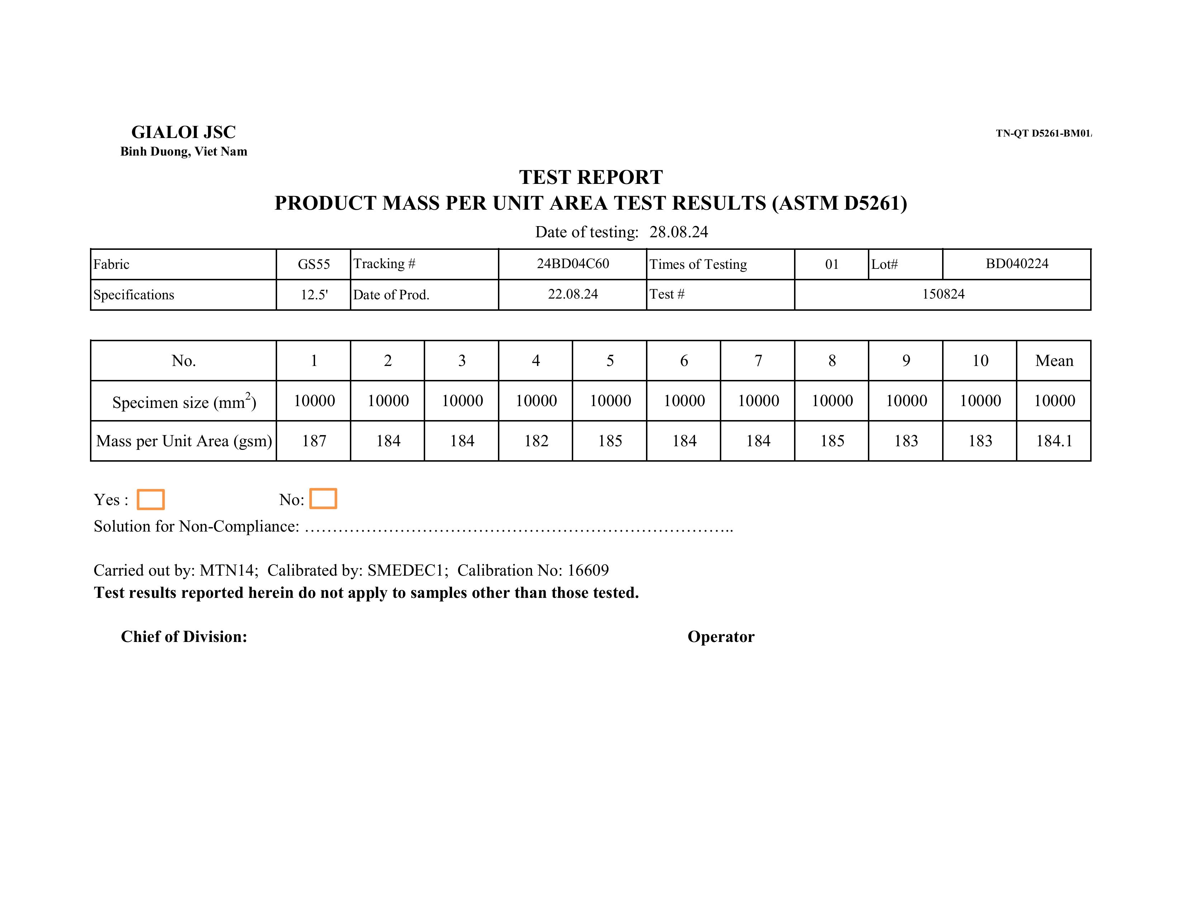

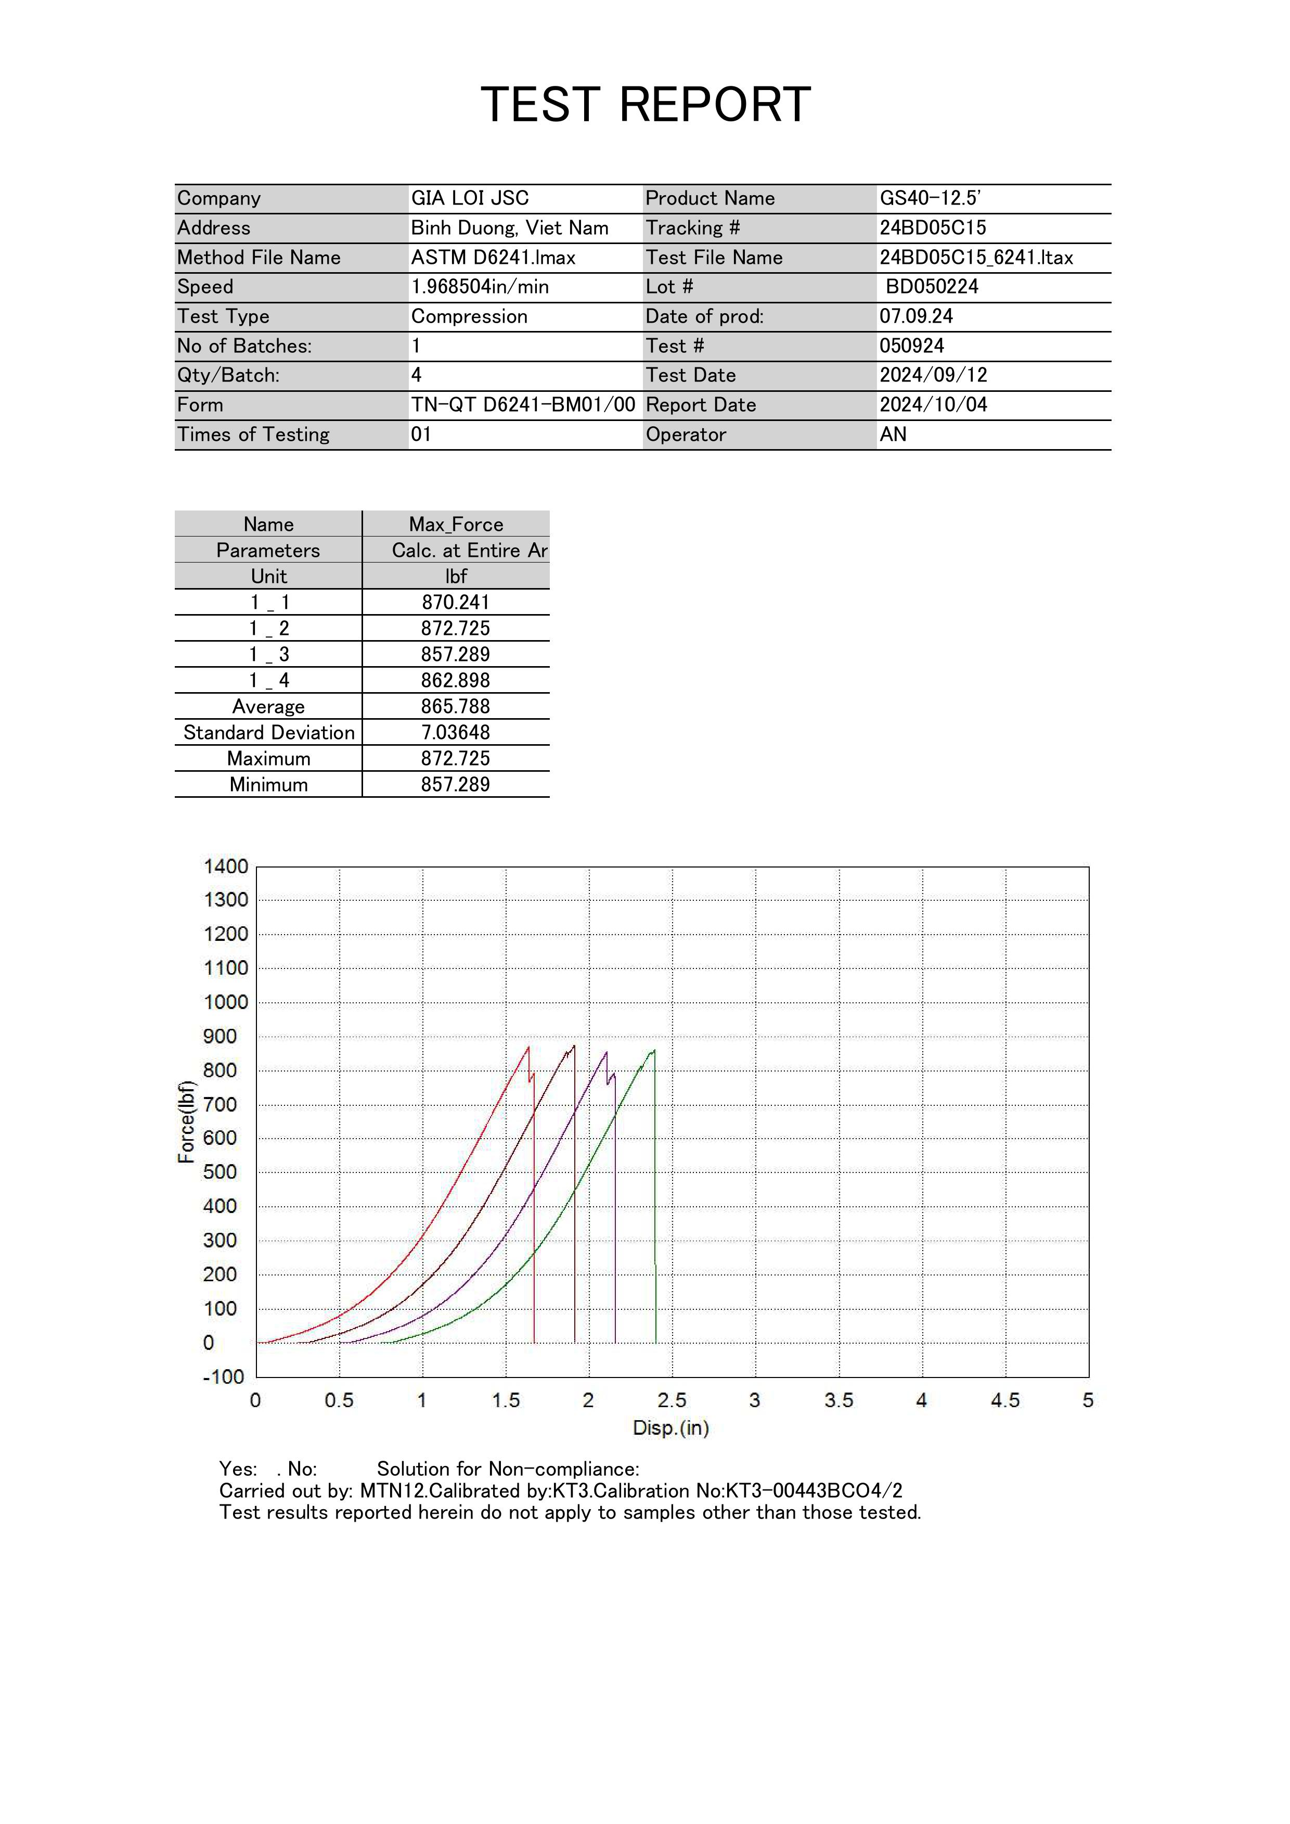

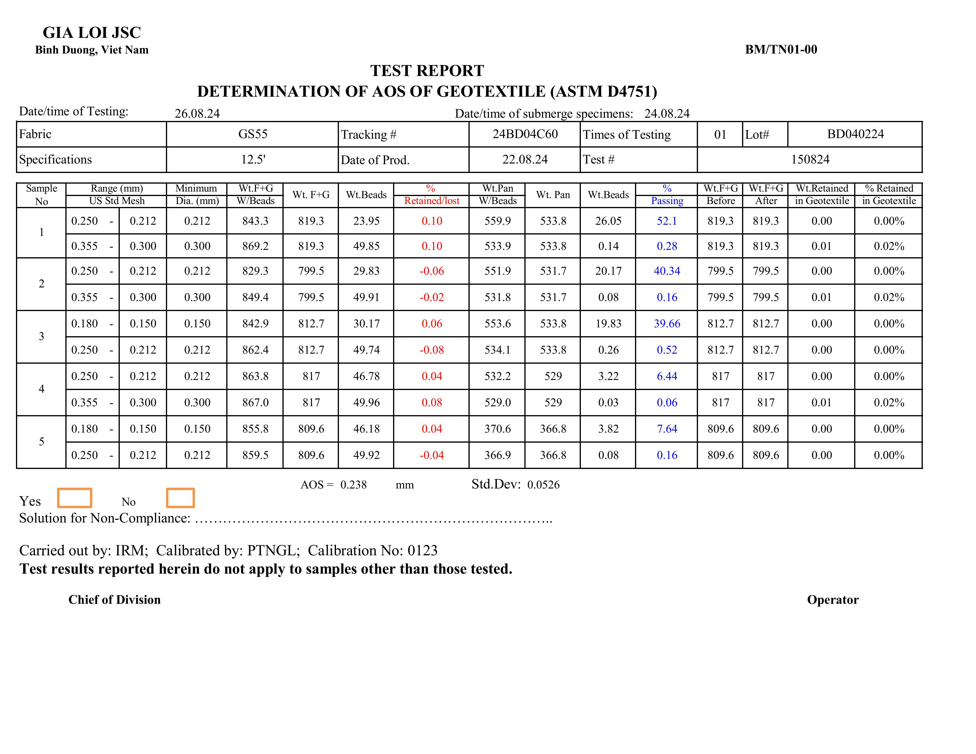

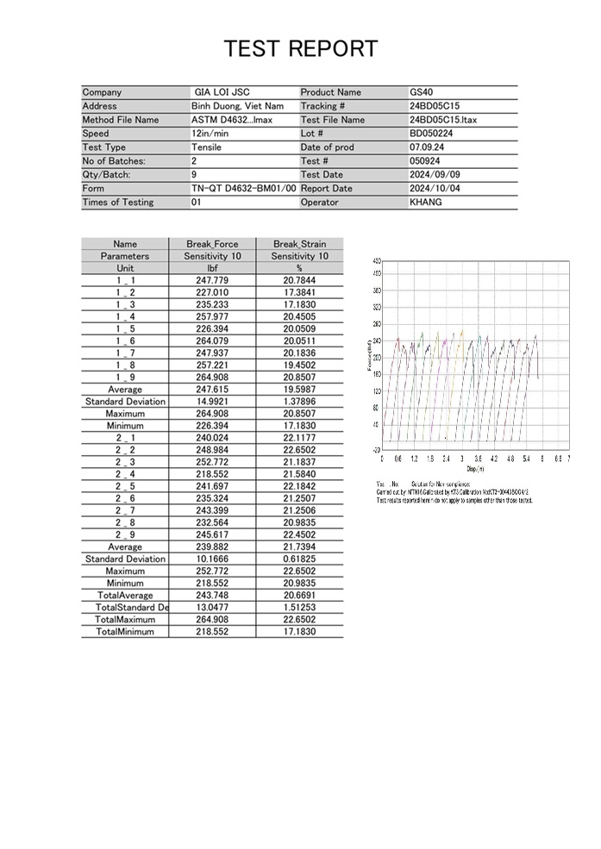

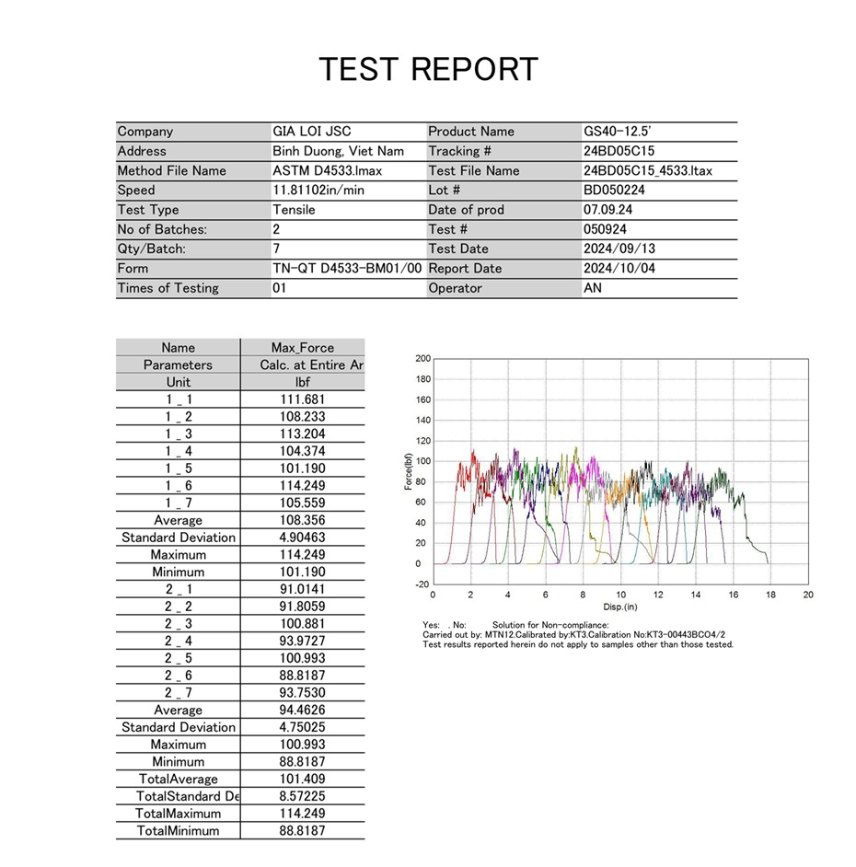

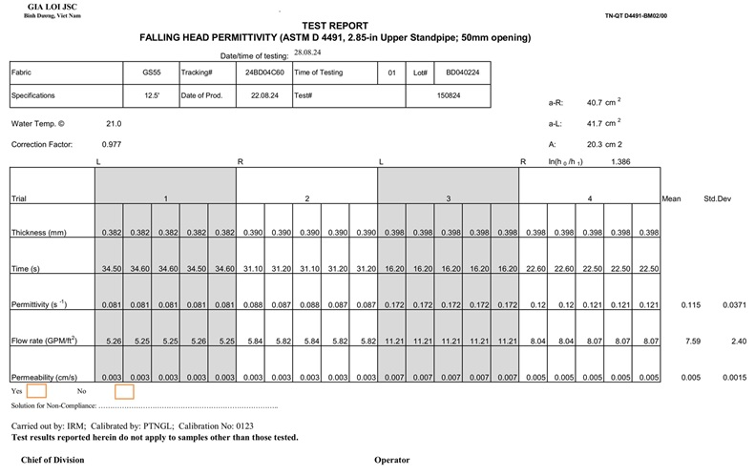

**Section 6: Signature**

|  |  |  |  |  |  |  |  |  |  |
| --- | --- | --- | --- | --- | --- | --- | --- | --- | --- |
| Signature: | |  | | | | Date: |  | | |
| ***I certify that all responses are truthful and accurate.*** | | | | | | | | | |
| Name: |  | | | | Title: | | |  | |
|  | | | | | | | | | |
| Plant Name: | | |  | Location (City, State): | | | | |  |